2 garment pockets golf cart bag
TH-Sport Golf Product
- 2 garment pockets golf cart bag
- Item:1015
- Material:High quality PU
- 7- way 9.5 "oval top
- Easy access porkets for storage
- Waterproof
- Cart sleeve prevents bag from twisting on cart
- Convenient putter clip
- Rainhood included
- High quality with fashion design
- Customers' brand are welcomed
- 3 months quality guaranteed
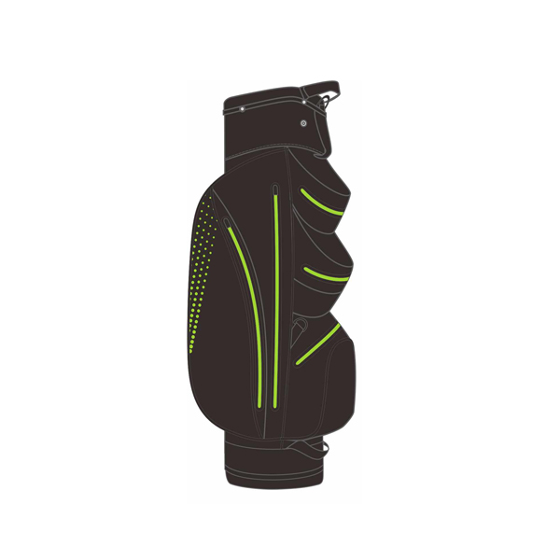
More information please click:www.tt-sport.com

