Cheap golf cart bag with waterproof
1. full length club dividers keep your clubs separated and protected; Heavy duty nylon construction ensures long lasting durabili
2. easy open/close magnetic pockets and (2) velour-lined, water-resistant valuables pockets
3.Power Pockets: back-up charge your electronic devices with included 10,000 mAh lithium-ion power pack
4.Includes dual Velcro glove holders, metal towel rings with built in bottle openers and umbrella holders
​
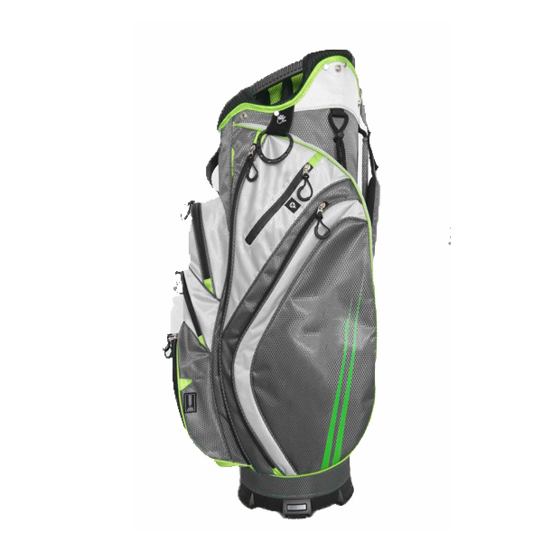
More information please click: www.tt-golf.com

