Custom material golf bag with stand
1.Imported
2.8 pockets are well designed for your valuables, big enough for Apparel, soft and waterproof for Smart phone and watches including 1 opened cooler pouch for beverage
3.club dividers keep clubs separated and secured
4.easy open/close magnetic ball pocket
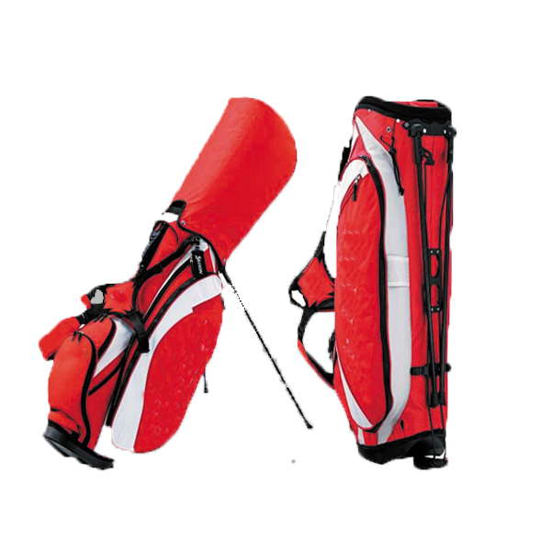
More information please click: www.tt-golf.com

