Item Name | Fashion hot sell unique animal golf head cover
Other Name | hot sell unique animal golf head cover
Material | PU/Polyester/Wool/Acrylic
Logo | Customer's brand is welcomed
Color | Black, Red, Yellow, Blue and so on.
MOQ: | 200sets
Packing | 1set/pe bag. 40sets/ctn
Weight: | N.W.: 20kgs G.W.: 21kgs
Carton Size | 50 x 50 x 60CM
Payment Term | T/T , L/C & DP

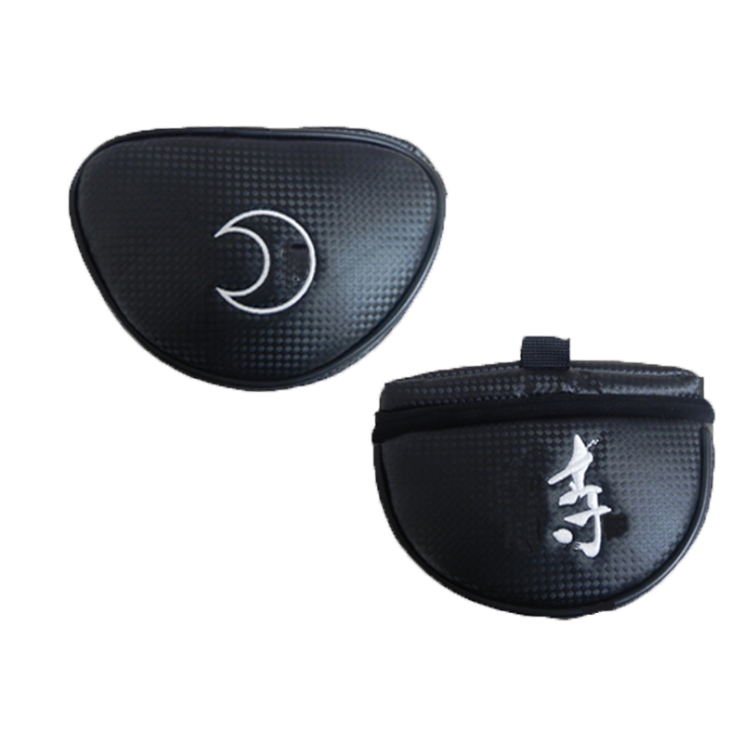
More information please click:www.tt-golf.com

