Fast delivery cheap golf culb set
1.13-piece package golf set complete with a driver, fairway wood, hybrid, 6-PW, putter, bag, and head covers
2.Right hand men's standard length on all clubs
3.Designed with the beginner golfer in mind
4.Matching head covers for driver, fairway wood, and hybrid,

5. Bag with waterproof, iron with steel.
6.Oversized 460cc titanium head with flex graphite shaft
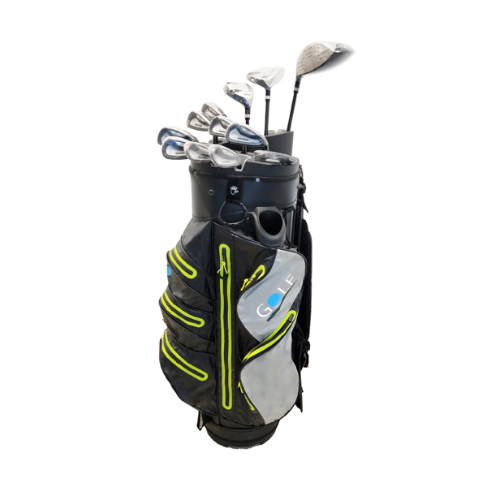
More information please click: www.tt-golf.com

