Newest golf cart bag
1.Newest golf cart bag
2.Item:9577#
3.Material:High quality PU
4.7- way 9.5 "oval top
5.Easy access porkets for storage
6.Waterproof
7.Cart sleeve prevents bag from twisting on cart
8.Convenient putter clip
9.Rainhood included
10.High quality with fashion design
11.Customers' brand are welcomed
12.3 months quality guaranteed
​
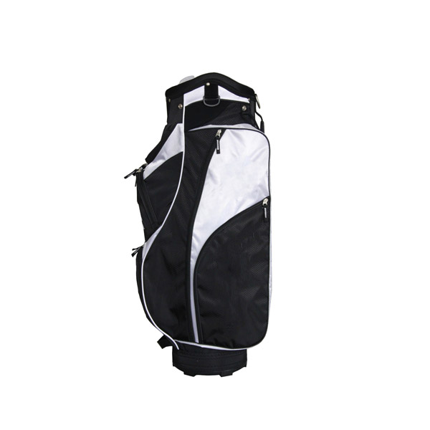
More information you can click：www.tt-golf.com

