OEM design standard golf iron grip
1.Classic wrap-style design
2.Windry polymer provides cushioning, comfort and non-slip, all-weather performance
3.High shock absorption
4.Weight: Junior 28g Ladies 35g Standard 48g Midsize 57g Oversize 63g

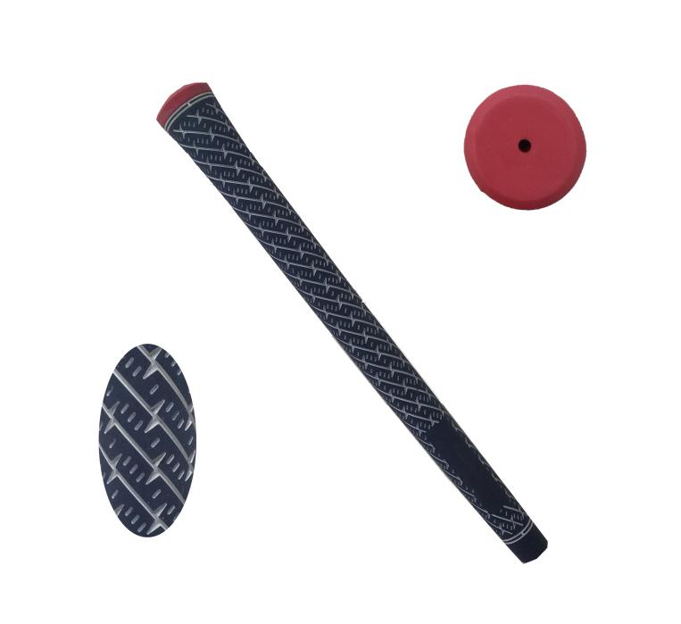
More information please click：www.tt-golf.com

