Product Type: | CHINA heated customizable logo and cabretta leather leather golf glove
Material: | cabretta leather
Model number: | TH-GL62
LOGO: | Embroidered/Rubber/Silicone/printing/empoxy meet your request
MOQ: | 500 pcs
Place of Origin | Fujian, China (Mainland)
Color: | colorful,can be custom
Brand name: | OEM
size: | s/m/l/xl/xxl
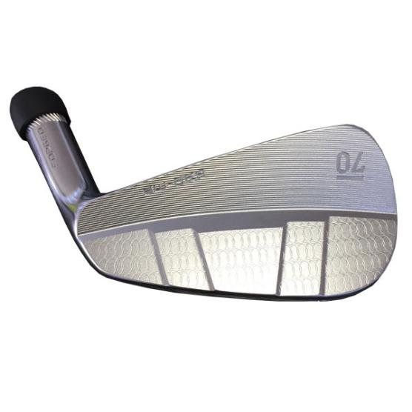
More information please click: www.tt-golf.com

