​Golf umbrellas

*62 PROFESSIONAL GOLF UMBRELLA - Canopy opens to a 62" arc, 51" diameter, it’s big enough to provide protection for many people for any weather condition from winter storms to the long hot days of summer. AUTOMATIC OPENING function just need simply press a button
*DOUBLE CANOPY –The double-canopy design allows the wind to pass through the vents preventing it from flipping over, making the umbrella much easier to handle in harsh conditions
*HIGH QUALITY MATERIALS- The surface is made of ultra-high density 190T pongee fabric coated with the best water repellent treatment - DuPont Teflon. The frames are a combination of electroplated steel shaft and premium resin-reinforced fiberglass ribs to provide the perfect balance of strength and flexibility to fight the wind
*COMFORTABLE & CONVENIENT DESIGN-The ergonomic handle provides comfortable grip for both left and right-handed users and fits into most golf cart umbrella mounts with a matching sleeve for convenient storage
*LIFETIME REPLACEMENT GUARANTEE-You are protected from the rain, strong breeze, sleet and snow using Rainlax umbrella. The Umbrella(s) That You Purchase will be Automatically Enrolled in our lifetime replacement guarantee program.

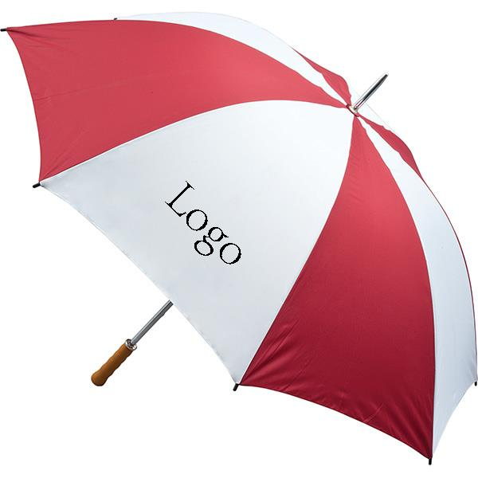
Company information
1998---A family business, a golf bag workshop, was founded, focusing on the local Chinese market.
2005---Moved to new 5000 square meter factory, employing 200 workers, with a production capability,
to produce 5000pcs per month.
2006---TH-SPORT (H.K.) was established, started to export our products world wide.
2008---Became partners with Grip, Glove, Cap & Umbrella factories.
2009---Started doing business with, Maxfli, Mercedes-Benz, Jaguar, Cleveland,Tommy Armour, Dunlop,
Hippo, Hello Kitty,Yamamoto, Ecco and a range of smaller companies.
2010---Opened a show room, to display all we have, on the pretty Xiamen Island, as a central convienent
location for our customers.
2016---We are focusing on developing high quality, innovative & fashionable golf products
Our Service
OUR ADVANTAGE:
1)We produce a range of High quality & fashionable products : We are consistently adding to our range, of
innovative & fashionable items. Having the highest quality is our first prority.
2) We are a Professional Manufacturer: we have been golf products manufacturer since 1998, we have a
wealth of experience.
3) Factory Price: You WILL benifit by our competitive pricing.
4)On time delivery: Being in manufacturing for more than 15 years, we have a wealth of experience, to control &
ensure, on time shipping .
5) Quality guarantee: Every order, we will offer a Pre production sample for quality confirmation before main production
FAQ
1.What is your main products?
Our main products are golf bag, headcover, club set, grip and other golf accessories, we offer OEM services.
2.What is your MOQ?
Our MOQ is usually 500 pcs
3.What is your time of making samples?
Usually we will take 2-3weeks to make the samples.

www.tt-sport.com

