Standard china cheap rubber golf iron grip
MATERIAL:RUBBER
SIZE:STANDARD
LOGO:OEM
COLOR:CUSTOM
CORE:0.58/0.60
LENGTH:267MM
WELCOME OEM DESIGN
TIMELY DELIVERY WITH COMPETITIVE FACTORY PRICES.
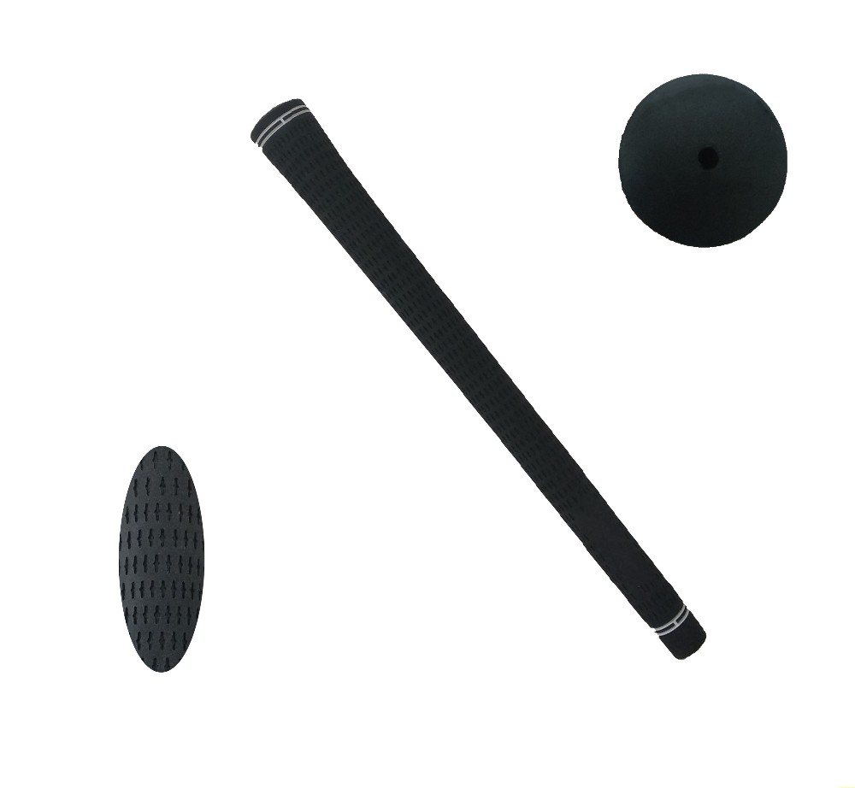
More information please click:www.tt-golf.com

