Standard colorful rubber golf iron grip
Material:reubber
size:standard
logo:oem
color:custom
core:0.58/0.60
length:267mm
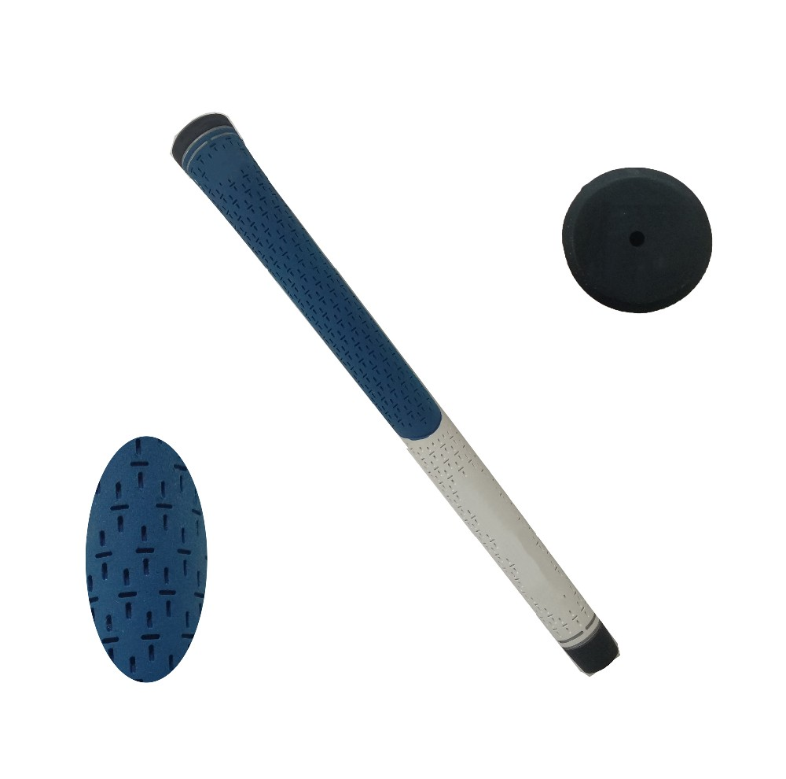
More information please click:www.tt-golf.com

